Sean Gordon

Arch 321

Module 2, Lecture 2 Response

This lecture focused on the influx of immigrant population to the US and the effect it had on the housing situation in cities.

As the population of cities skyrocketed, housing was found in the form of tenements. These densely packed buildings were occupied by multiple families and were a place to live and work for many of their residents. They were typically very cramped and had poor access to the outside for lighting and ventilation. There was little regulation, and many of these buildings became a representation of greed.

An immigrant in the US faced major discrimination and, in cases like the Jews or African Americans, were limited to housing in certain areas of the city. This was apparent in the lower east side of Manhattan, the most high-density location in the world at the time. This resulted in grungy living conditions, with many decaying buildings packed with people.

Pushes for reform began to arise, some of them spearheaded by photographs by Jacob Riis, showing the dense living conditions endured and inciting the sympathy of those who may not have known such conditions existed. Regulation efforts brought about dumbbell shaped tenements to increase light and airflow into the buildings, and attempts at larger, better buildings with hopes of bettering the living conditions in parts of the city.

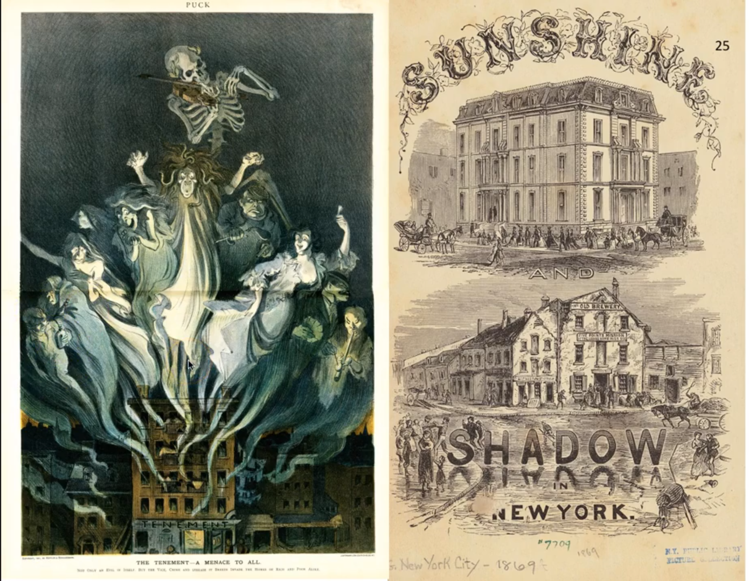

This graphic shows an example of what some worried tenements to be, breeding grounds for death, disease, and unhealthy choices. Opinions like these pushed for reform across the city to better living conditions.

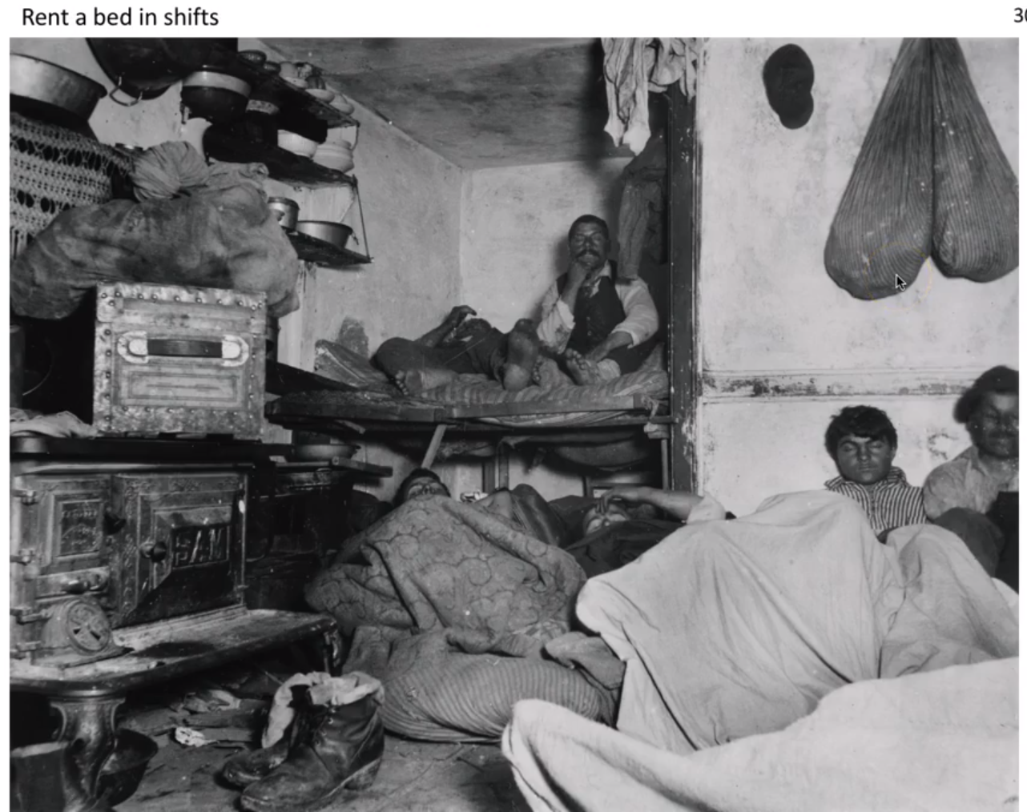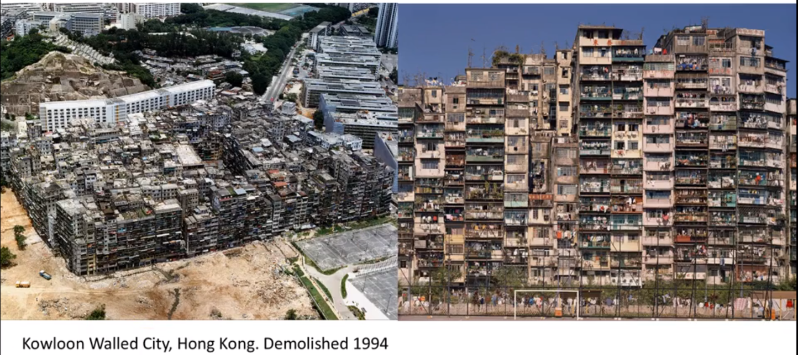

These images show examples of how extreme unregulated housing can get. The left opened peoples eyes to the realities of dense living in New York, while the right is the infamous unregulated Kowloon Walled City in Hong Kong.